FIRST 2020 25th year!!! Oh Yeah!!!
Team Meeting 10/4/19 FIRST Website_www.usfirst.org Team website_www.tj2.org
Officers: Strategy Captain –Anthony Buttafoco Build Captain –Shay Mitton Outreach Captain –Morgan Chase Programming Captain – Mackenzie Pryor Art Captain – Mason Ricci Media Captain – Mike Daversa
Coaches , Engineers & Volunteers: Mrs. Calef ( Lcalef@bridge-rayn.org),Mrs. Hall (anniem81949@yahoo.com), Ms. Jerome, Mr. Jahnke, Mr. Stewart, Mrs. Wood, Mr. Hall, Mr. Calef, Mr. LaMothe, Mr. Avtges, Dr. Tully, Pat Koczela, Tom Calef, Steve Viera, Doug Stewart, Brad Wall,, Eric Theberge, Mrs. Theberge, Trevor Kelly, Julian Plante, Dr. Joe Johnson Friends of TJ2 Robotics -FOTJ2R – a 5013C friends support group- President: Scott Rubin, Treasurer: Janet McGrail, Secretary: Heather Charland – Board of Directors: Ellen Wood, Janet McGrail, Heather Charland, Brad Wall, Nick Avtges, Eric Theberge, Doug Stewart, Scott Rubin - Twitter page https://twitter.com/frcteam88 Google Classroom : kvjqh0

ATTENTION: When shopping on Amazon.com, if instead you go to www.smile.amazon.com and declare Friends of TJ2 Robotics, Inc., your charity…..0.5% of every purchase will to FOTJ2R without costing you anything!!!!! Please tell all your family and friends.

Team Meetings: 10/18, 11/1, 11/15, 12/13, ¼, 1/5, 1/10, 1/24, 2/7, 2/28, 3/6, 3/20, 4/3, 4/16, 5/1, 5/15, 5/29 -elections, 6/12 *mandatory meetings!!!
Friday, Oct 18-last day to sign up for team this year!!!
All registration documents are due!!!
Group Attendance, minimum hours, fundraising…….
Upcoming Schedule: see Google Calendar- http://www.tj2.org/calendar
Auction-
set up day Thu, Dec 5 2-6pm-Mandatory, Auction Fri, Dec 6 5:30-11pm ***Sign up Classroom
Auction items due by 11/8 (1 per student value >$25), Auction tickets sold by 11/15 (>=2 per student)

Tickets due 11/18/19
Auction Item due 11/8/19
Volunteer - ****sign up Classroom set up at Vets club, day of auction
Mandatory – load in after school 12/5/19
Art Group – Monday 2-4pm Rm B204 – Mrs. Wood. -starts 9/9
Order sweatshirts now- ***Sign up Classroom
Ethics - Review Ethics contract, make changes, vote to accept/reject
Build Training - see google calendar (select Tues 6-9pm, Thu 6-9pm, Sat 9-3pm) ****sign up Classroom
Programming - see google calendar (select Wednesdays) 6-9pm Rm D134 ****sign up Classroom
PR Group- Tuesday 5-6pm D134 – MS. Charland – starts 9/17****sign up classroom
Strategy Group – selected Tuesdays…..to be announced.
Beantown Blitz – Saturday, Oct 19th be at back parking lot at 5:45am, we will return to BR by 8pm ***Sign up Classroom
River Rage – Saturday, Oct 26th be at back parking lot at 5:45am, we will return to BR by 8pm ***Sign up Classroom
Costume?
Halloween Happenings
– Tues., Oct 29th- 4:30pm-8pm- need lots of help = double time since outreach***Sign up Classroom
STEAM Day – Friday of MA STEM Week – 10/25/20 – out of school 10/25 ***Sign up Mr. LaMothe
Lego League - RMS - 2 teams - Mr. and Mrs. Leighton-awesome!!!, BMS Lego League Club- Mr. Souto need help!!!
Lego League Jr. - 1 team Bridgewater and Raynham - Mr. Lucia head coach – first meeting happened!!!
Competitions:
SE MA NE District Event at BRRHS 3/5-8, 2020- out of school 3/6 to help set up
NE District Events (2, 1 TBD)
NE District Championship Springfield, MA. if we qualify 4/8-11/2020 -out of school 4/9,10/2020
World Championship in Detroit if we qualify 4/28-5/3 -out of school 4/29, 4/30, 5/1
Indianapolis Invitational Robotics Comp (IRI) if we get invited 6/24-28/20 students pay that are able.

Ethics and Robotics Teams – a Lesson!
Goal: to develop a relevant code of ethics that students own and embrace as their own.
-to develop a method of keeping the code alive on the team
-to develop a method of passing this code to future teams, making it an important tradition of the team

TJ² Member Code
General Guidelines for Team member
· Contribute to welcoming atmosphere and feel of the team
· Do not misuse team or school equipment/facilities
· Value honesty and integrity
· Absolutely never bully, exclude, or discriminate against teammates, members of FIRST Robotics or anyone
· Have knowledge of all rules and regulations both in your school and at FIRST events and report any violations of them
· Fulfill all obligations and responsibilities to the best of your ability
· Accept responsibility for your actions
· Understand and follow the general ethics rules of FIRST
· Code of Conduct FIRST Robotics
FYI
The FIRST mission is to inspire a generation of science and technology leaders who are both gracious and professional. This FIRST Code of Conduct lists some of the basic behaviors mentors, coaches, volunteers, team members, affiliate partners, contractors, staff, and other participants should adhere to while participating in FIRST activities.
- Exhibit Gracious Professionalism® at all times. Gracious Professionalism is a way of doing things that encourages high-quality work, emphasizes the value of others, and respects individuals and the community. With Gracious Professionalism, fierce competition and mutual gain are not separate notions.
- Ensure the safety of all participants in FIRST activities.
- Not engage in any form of bullying, harassment, use of profane or insulting language, or any actual or threatened violence.
- Adhere to all FIRST Youth Protection Program (YPP) policies.
- Report any unsafe behavior to event or local FIRST leadership.
Persons who do not comply with this Code of Conduct may be barred from participating in FIRST activities.

General Ethics for Leaders
· Encourage the team and help members in understanding their own roles and ethics
· Help create opportunities for others to learn and experience all aspects of FIRST and STEAM as a whole
· Assist struggling or isolated members as well as develop trust with everyone
· Role model acceptable behavior by following all ethical rules and promoting an environment of toleration and acceptance
· Communicate and interact with all members and aspects of the team
Ethics for Competitions
· Always act with Gracious Professionalism
· Help others whenever you get the chance
· Treat other teams with respect and kindness
· Lift others up rather than tear them down
· Always keep your cool
· Do your best
· Behave responsibly
Ethics for interacting with community
· Always be truthful and thorough when making statements to the community
· Show the values of FIRST during interactions and follow all other ethical guidelines
· Act to help the public in education or the spreading of FIRST values. Always be willing to assist
· Honor to the best of your abilities all commitments and agreements between the team and an outside source
· Set a good example for FIRST and your FIRST team
Ethics for Robot Creation
· Never build something inherently dangerous or leave something in such a state that it would easily become a danger
· Assign credit where credit is due. Never allow the hard work of another to be stolen or copyright infringed.
· Ensure the workplace is completely safe and secure
· Treat every team with respect
· Offer help to others

Method to bring code to team consciousness
Two sided badge with TJ2 Lanyard to be worn whenever acting as part of the TJ2 Robotics Team.
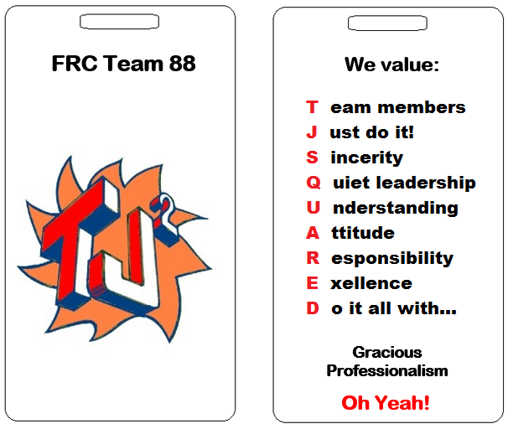
Method for Future Teams
First meeting after election of captains – review code.
Team votes to adopt code
Full rewrite every four years

I agree to conduct myself in a manner that reflects this code of ethics as long as I am a member of
The BRRHS TJ² Robotics Team FRC #88.

Member Signature ____________________________ Date ___________________________
Member Name Printed _________________________

