FIRST 2022 27th year!!! Oh Yeah!!!

Team Meeting 9/24/21 FIRST Website-www.firstinpires.org Team website-www.tj2.org
-------------------------------------------------------------------------------------------------------------------------------
Officers:
Coaches , Engineers & Volunteers: Mrs. Calef ( Lcalef@bridge-rayn.org),Mrs. Hall (anniem81949@yahoo.com), Ms. Jerome, Mr. Jahnke, Mr. Stewart, Mrs. Wood, Mr.Delmonte, Mr. Calef, Mr. LaMothe, Mr. Avtges, Pat Koczela, Tom Calef, Steve Viera, Heather Charland, Doug Stewart, Brad Wall,, Eric Theberge, Mrs. Theberge, Trevor Kelly, Paul Terasi, Dr. Joe Johnson , Ben Warwick, Andras Pungor, Bob Spurr,

Friends of TJ2 Robotics -FOTJ2R – a 5013C friends support group - President: Scott Rubin, Treasurer: Kerri Spurr, Secretary: Heather Charland – Board of Directors: Bill Wood, Heather Charland, Brad Wall, Nick Avtges, Eric Theberge, Doug Stewart, Scott Rubin, Bob Spurr, Kerri Spurr, Don DeLutis, and Gretchen DeLutis.
Twitter page https://twitter.com/frcteam88 Google Classroom : z6pvwas
-------------------------------------------------------------------------------------------------------------------------------
ATTENTION: When shopping on Amazon.com, if instead you go to www.smile.amazon.com and declare Friends of TJ2 Robotics, Inc., your charity…..0.5% of every purchase will to FOTJ2R without costing you anything!!!!! Please tell all your family and friends.

Team Meetings: Fridays bi-weekly at 2:15pm BRRHS Rm H103

Meeting agendas will be posted on our website at https://www.tj2.org/team-meetings

Calendar link: https://calendar.google.com/calendar/u/0/r/month/2021/9/1

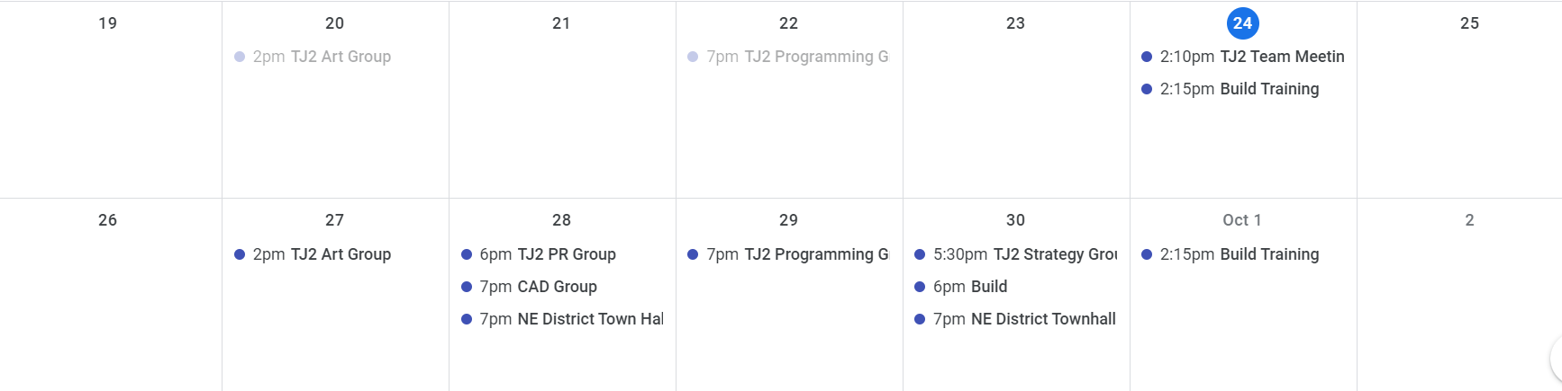
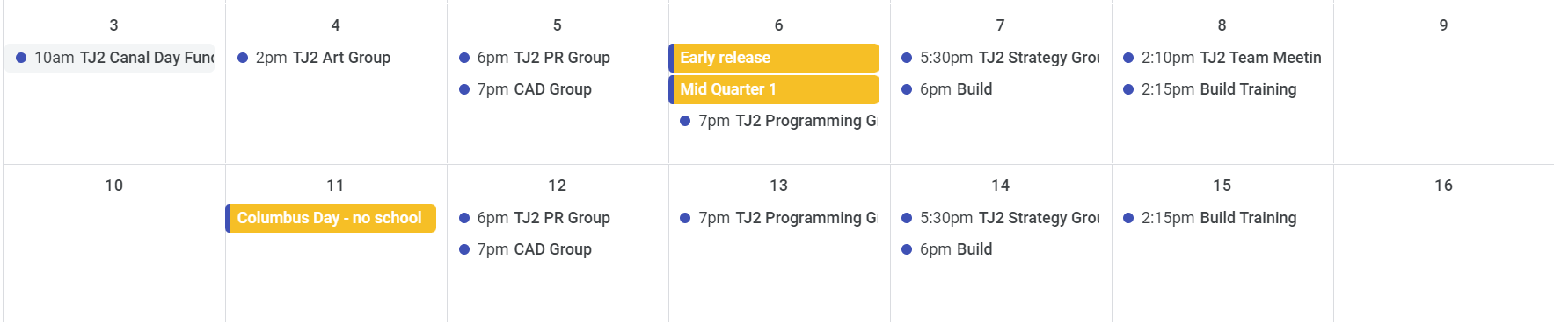

Officer Elections – we are planning on having leaders picked in each group. The group leaders will then meet and pick a team captain. The group leaders led by the team captain will be the student leadership group. This will happen in October once the groups have been established.

Fundraising – in past years we have needed student members to raise $700 to be part of the travel team and $400 to be a member of the team. In addition to this, there is a $50 user fee that is paid to BRRHS to be part of a team. This $50 does not go to the team, it goes to the district for expenses.
At this time we don’t have a plan for fundraising.
Our first event is Canal Day – Oct 3rd. Collect sponsors and the money you collect will go to your account. You will have to pay the $50 club fee- we will tell you when that is due.

NE District Events – just published today!
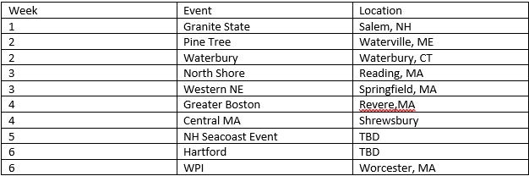

Ethics and Robotics Teams – a Lesson!
Goal: to develop a relevant code of ethics that students own and embrace as their own.
-to develop a method of keeping the code alive on the team
-to develop a method of passing this code to future teams, making it an important tradition of the team

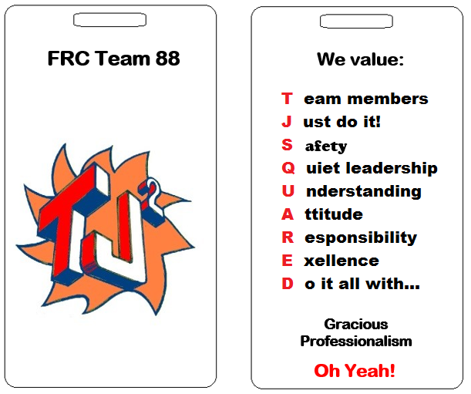
TJ² Member Code
General Guidelines for Team member
• Contribute to welcoming atmosphere and feel of the team
• Do not misuse team or school equipment/facilities
• Value honesty and integrity
• Absolutely never bully, exclude, or discriminate against teammates, members of FIRST Robotics or anyone
• Have knowledge of all rules and regulations both in your school and at FIRST events and report any violations of them
• Fulfill all obligations and responsibilities to the best of your ability
• Accept responsibility for your actions
• Understand and follow the general ethics rules of FIRST
• Code of Conduct FIRST Robotics
FYI
The FIRST mission is to inspire a generation of science and technology leaders who are both gracious and professional. This FIRST Code of Conduct lists some of the basic behaviors mentors, coaches, volunteers, team members, affiliate partners, contractors, staff, and other participants should adhere to while participating in FIRST activities.
• Exhibit Gracious Professionalism® at all times. Gracious Professionalism is a way of doing things that encourages high-quality work, emphasizes the value of others, and respects individuals and the community. With Gracious Professionalism, fierce competition and mutual gain are not separate notions.
• Ensure the safety of all participants in FIRST activities.
• Not engage in any form of bullying, harassment, use of profane or insulting language, or any actual or threatened violence.
• Adhere to all FIRST Youth Protection Program (YPP) policies.
• Report any unsafe behavior to event or local FIRST leadership.
Persons who do not comply with this Code of Conduct may be barred from participating in FIRST activities.

General Ethics for Leaders
• Encourage the team and help members in understanding their own roles and ethics
• Help create opportunities for others to learn and experience all aspects of FIRST and STEAM as a whole
• Assist struggling or isolated members as well as develop trust with everyone
• Role model acceptable behavior by following all ethical rules and promoting an environment of toleration and acceptance
• Communicate and interact with all members and aspects of the team
Ethics for Competitions
• Always act with Gracious Professionalism
• Help others whenever you get the chance
• Treat other teams with respect and kindness
• Lift others up rather than tear them down
• Always keep your cool
• Do your best
• Behave responsibly
Ethics for interacting with community
• Always be truthful and thorough when making statements to the community
• Show the values of FIRST during interactions and follow all other ethical guidelines
• Act to help the public in education or the spreading of FIRST values. Always be willing to assist
• Honor to the best of your abilities all commitments and agreements between the team and an outside source
• Set a good example for FIRST and your FIRST team
Ethics for Robot Creation
• Never build something inherently dangerous or leave something in such a state that it would easily become a danger
• Assign credit where credit is due. Never allow the hard work of another to be stolen or copyright infringed.
• Ensure the workplace is completely safe and secure
• Treat every team with respect
• Offer help to others

Method to bring code to team consciousness

Two sided badge with TJ2 Lanyard to be worn whenever acting as part of the TJ² Robotics Team.

Method for Future Teams
First meeting after election of captains – review code.
Team votes to adopt code
Full rewrite every four years

I agree to conduct myself in a manner that reflects this code of ethics as long as I am a member of
The BRRHS TJ² Robotics Team FRC #88.

FRC Kickoff - Jan 8th – 9:30am

